Anti-Mullerian Hormone（AMH）

anti-Mullerian hormone,AMH is a member of the TGF β superfamily, first discovered by Professor Alfred Jost in 1974. AMH is a disaccharide protein composed of two identical 70 KD subunits connected by disulfide bonds. The relative molecular weight is 140 KD; and the human AMH coding gene is located in the short arm of chromosome 19. The size is 2.4~2.8 and contains five exons.
anti-mullerian tube hormone (AMH) plays an important role in gonadal organ development and is one of the important markers of gonadal function in men and women. The male AMH is mainly produced by leydig cells, which begins with embryo formation and runs through life all the time. During the development of male fetus, AMH leads to the degeneration of Muller's tube and the formation of normal male reproductive tube. The female AMH is mainly produced by ovarian granulosa cells, and the serum AMH remains a lower level than that of men. From puberty, the serum AMH level decreases slowly over time and decreases to levels not detected by ELISA method.

Application of AMH indicators:
AMH is a good index to evaluate the function of ovarian reserve easy to use.
AMH can predict menopausal age.
AMH provide a new reference for the diagnosis of polycystic ovary syndrome (PCOS) in China.
AMH is of great significance in the diagnosis of premature ovarian failure, ovarian granulosa cell tumor and sexual dysplasia in children.
AMH can accurately predict ovarian response before assisted reproductive technology (ART), formulate individualized stimulation programs, improve pregnancy rate to a certain extent, and reduce the risk of complications.

Advantages of AMH indicators
- Not affected by the menstrual cycle, can be tested at any time
The FSH、LH、E2 changes with the menstrual cycle, usually on the third day of menstruation, while the AMH is not affected by menstrual cycle, pregnancy, medication, etc., and the concentration is the same at any time.

- It can clearly know the storage rate of the ova The FSH、LH is to evaluate ovarian function indirectly according to the principle of hormone regulation. It can only roughly understand the good and bad ovarian function, but AMH exists in follicular granulosa cells.
The actual age of women is not exactly equal to ovarian age, let alone ovarian reserve function. There are also examples of older but young ovaries, whose ovarian reserve function is still good. Therefore, clinical needs more efficient, accurate and stable detection to have a more comprehensive evaluation and understanding of ovarian reserve function.
The higher the AMH index, the greater the stock of eggs, the stronger the fertility, and the AHM index decreases, it represents the aging of the ovary, that is, the decline of female fertility.

- Potential for development in reproductive medicine
AMH in artificial conception or IVF treatment is used to provide follicle data obtained after ovulation stimulation. Through AMH values, doctors can use ovulation injections and drugs at their discretion, and can also provide clear advice when consulting patients.

Normal value of AMH
The normal value of AMH is between 2-6.8ng/ml. The higher the AMH value, the more abundant the egg stock and the longer the golden period suitable for conception. The lower the AMH value, the worse the ovarian function. After 35 years of age, the AMH value will be It begins to drop sharply. When the AMH value is lower than 0.7ng/ml, it indicates that the egg inventory is seriously insufficient and it is almost difficult to conceive.
If the AMH value is greater than 6.8, the constitution of polycystic ovary syndrome can be considered. When using ovulation injections and drugs, the ovaries are also prone to overreact and discharge too many eggs, resulting in ovarian hyperstimulation syndrome.

Clinical significance of AMH
Modern people live under pressure, in addition, various factors of the environment, Women’s ovarian function declines earlier and earlier. In addition, modern people generally get married late, and ovarian primordial senility has seriously threatened women’s chances of pregnancy. Under normal circumstances, women’s ovarian function does not begin to decline until about 45-50 years old. If signs of decline appear before the age of 40, it is the so-called premature ovarian failure, which not only affects pregnancy, but also prompts women to face aging earlier. Maintaining good living habits is very important for ovarian conditioning. Try to maintain a normal schedule, do not stay up late, do not smoke, stay away from various pollutants, learn to relieve stress; regular exercise is good for your health. However, women with normal BMI (body mass index) should not engage in vigorous exercise for more than 4 hours a week, so as not to cause female hormone disorders. If you find any changes in your menstruation, such as oligomenorrhea, oligomenorrhea, etc., you should seek medical advice as soon as possible.

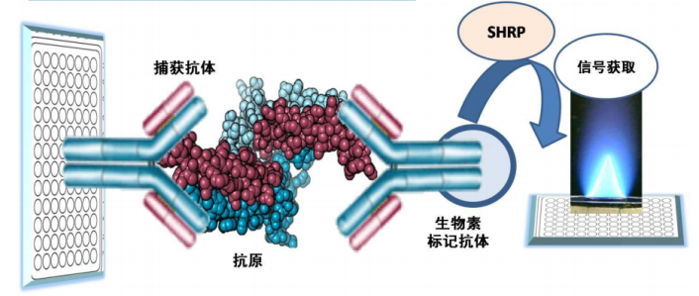

Inspection principle:

The kit uses a three-step sandwich enzyme-linked immunoassay for quantitative detection: In the first step, the standard, quality control and sample are added to the antibody-coated microwells and incubated. After the first incubation and washing, the biotin-labeled antibody is added to the microwells and incubated.
After the first incubation and washing, the biotin-labeled antibody is added to the microwells and incubated.
After the third incubation and washing, add chromogenic solution (TMB) for incubation, and then add acidic stop solution to end the reaction. Theoretically, the antibody-biotin conjugate is combined with the solid-phase antibody-antigen complex and then combined with the streptavidin-horseradish peroxidase conjugate. In this way, the antibody-antigen-antibody biotin complex-SHRP is bound to the micropores and detected by the enzyme-substrate reaction. The degree of reaction between the enzyme and the substrate is determined by the dual wavelength with the dominant wavelength of 450nm and the reference wavelength of 630nm. The measured absorbance reflects the concentration of the detected substance in the sample and the calibrator, and is positively correlated, by establishing a logarithm-logarithm The standard curve equation is used to obtain the concentration of the hormone in the sample to be tested.

